Standard Operating Procedure: Slicing an Apple into Sections and Slices
Derived procedure. This document was not authored. It was synthesized from 3 observed runs, and every step, action and decision point below was performed by an operator on video. The figure captions give the run and timestamp each illustration came from. Coverage notes such as “observed in 2 of 3 runs” indicate how consistently something was done, and are the reader’s guide to how firm each instruction is.

1. Prepare the apple
Confirm the apple is fit for use and get set up for the first cut.
Observed in 2 of 3 runs.

1.1 Inspect the apple
1.1.1 Pick up the apple and examine it for bruises, blemishes, or other defects.
1.1.2 Confirm the apple is whole and suitable for cutting.
Decision points
If | Then
a bruised spot is found on the apple's skin | plan to cut on the bruised side of the apple first
the apple is inspected and found whole with no concerning defects | proceed to cut the apple without alteration

1.2 Position for the first cut
1.2.1 Hold the apple upright on the board with one hand.
1.2.2 Bring the knife into position at the side of the apple with the other hand, ready to cut.

2. Cut a section from the apple
Separate a large section from the apple or core piece so it can be trimmed and sliced.
Observed in 3 of 3 runs. Repeat for each section cut from the apple (typically twice per apple, working around the core piece).
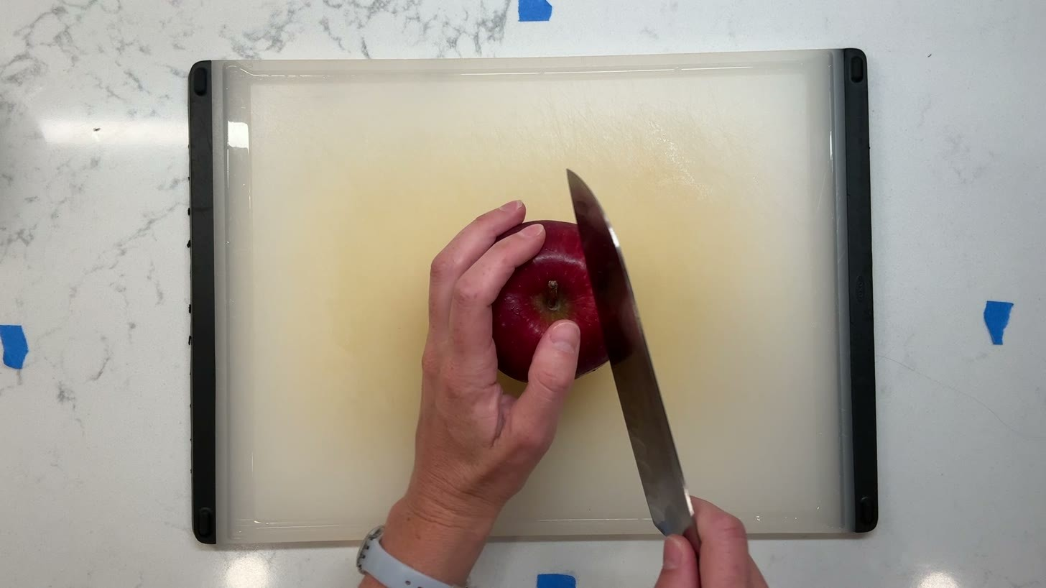
Figure 2.1. Cut a section from the apple — molly3, t=9s

2.1 Position the apple or core piece for cutting
2.1.1 Hold the apple or core piece upright in one hand, presenting an uncut face toward the blade.
2.1.2 Adjust your grip so the stem is clear of the intended cut line.
Decision points
If | Then
the apple's stem sits in the path of a straight cut | angle the cut beside the stem rather than straight through the top of the apple

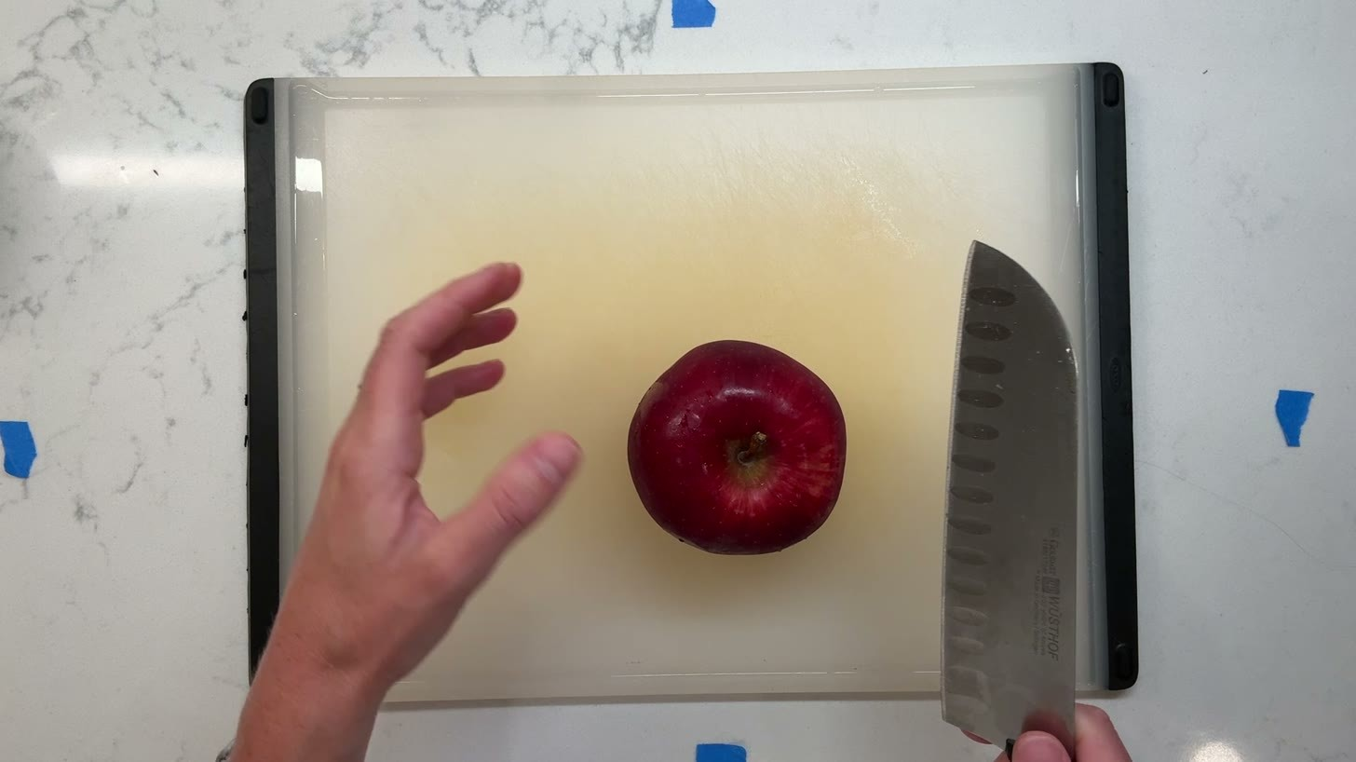
Figure 2.2. the apple's stem sits in the path of a straight cut — molly3, t=7s

2.2 Cut the section free
2.2.1 Press the knife blade into the top of the apple or core piece, beside the stem if needed.
2.2.2 Draw the blade straight down through the apple in one stroke, cutting a section free from the core piece.
2.2.3 Lift the section and core piece apart slightly to check the cut.
Decision points
If | Then
the cut is running close to the core | keep the cut away from the core to avoid slicing into it

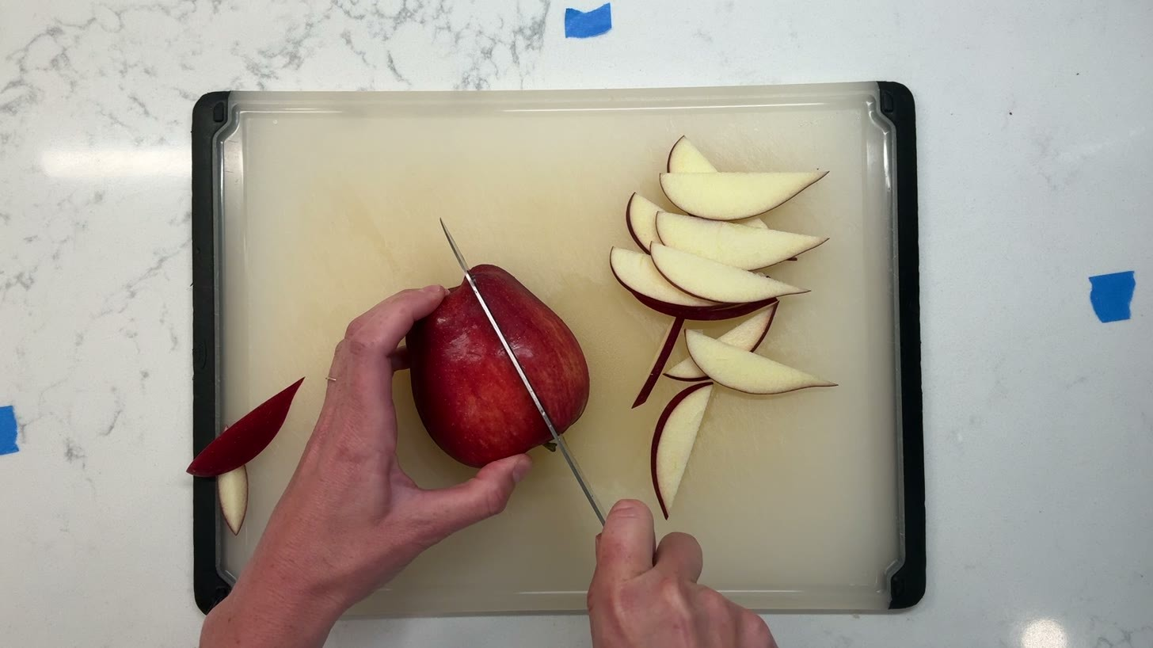
Figure 2.3. avoiding cutting too close to the core — molly2, t=32s

2.3 Inspect and set aside the core piece
2.3.1 Turn the core piece to inspect its cut face for bruising.
2.3.2 Set the core piece aside on the board (e.g. top-left), skin side up, and keep it for cutting the next section.
Decision points
If | Then
the cut face shows minor bruising | judge it acceptable and continue without further action

3. Cut slices from the section
Reduce each section into individual slices of consistent, usable size.
Observed in 3 of 3 runs. Repeat for each section of the apple, and for each slice cut from that section.
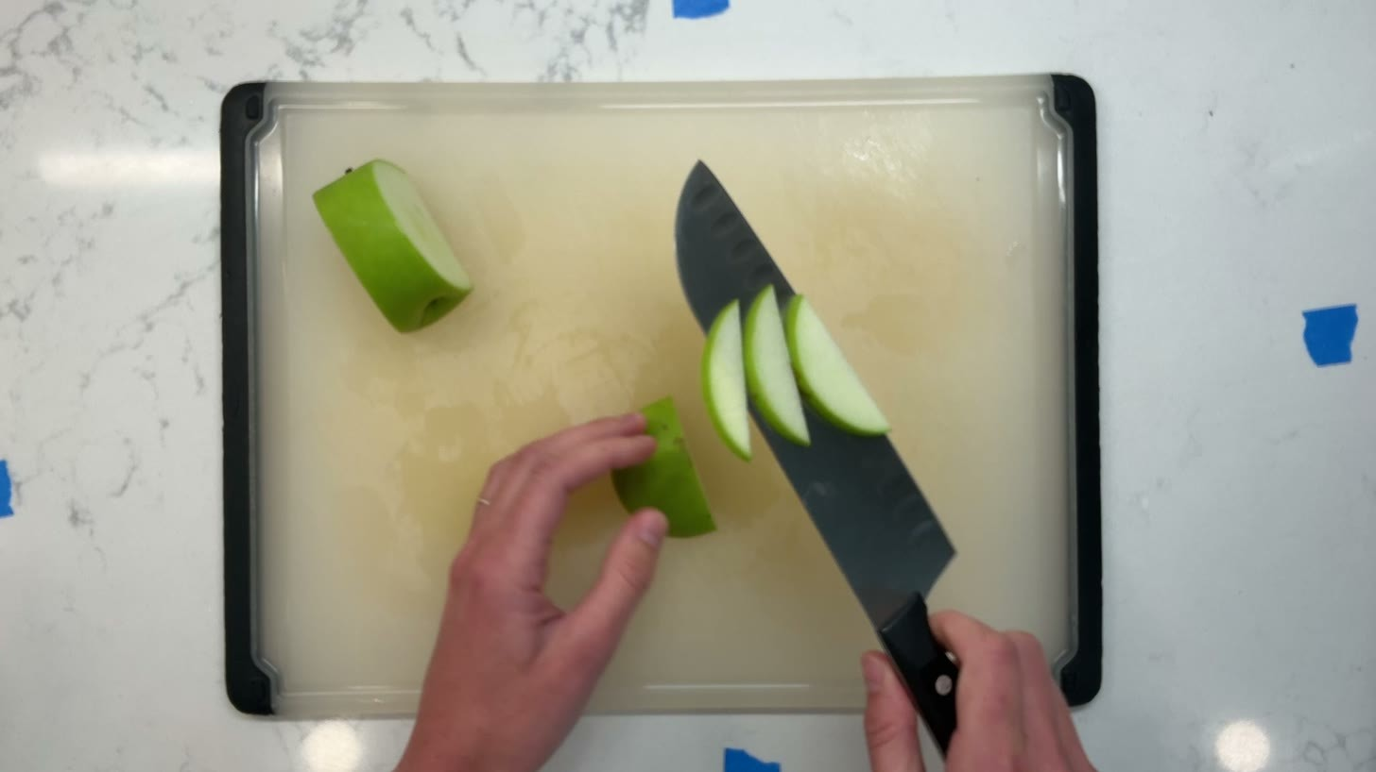
Figure 3.1. Cut slices from the section — molly1, t=36s

3.1 Trim scrap from the section
3.1.1 Hold the section upright in one hand, cut face oriented toward the blade.
3.1.2 Draw the blade down along the rounded or blemished edges of the section, cutting away thin scraps of skin.
3.1.3 Set trimmed scrap aside, separate from the slices.
Decision points
If | Then
the section shows bruising | cut away the scrap of skin covering the bruise before slicing
a mark on the skin looks like frost rather than bruising | continue slicing without additional trimming
bruising on the cut face turns out less severe than expected | continue cutting the section as normal

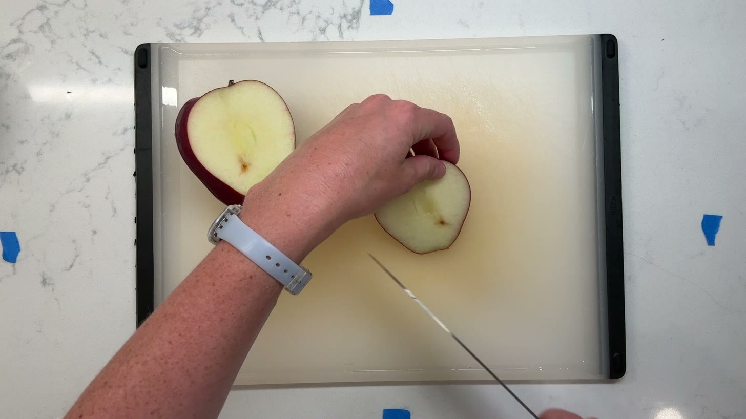
Figure 3.2. the section shows a weird bruising — molly3, t=13s

3.2 Cut slices from the section
3.2.1 Start cutting from the bigger end of the section; avoid starting from the smaller end, as this makes it harder to judge the size of each cut and to see it clearly while cutting.
3.2.2 Cradle the section in one hand, presenting a fresh face to the blade.
3.2.3 Press the knife down through the section in a single stroke, cutting a slice free.
3.2.4 Guide or let the slice fall onto the board, joining the fan of slices.
3.2.5 Rotate the section slightly in hand after each cut to present a new face, and repeat until the section is reduced to a small remnant.
Decision points
If | Then
a slice starts coming out bigger than the others but is still within tolerance | judge it acceptable and continue cutting the same way
a cut slice is judged too thin to count as usable product | set it aside as scrap instead of keeping it with the slices
the remaining piece of the section becomes too small to cut further | set it aside as scrap rather than continuing to cut it
the remaining piece looks small but is judged still large enough | cut one more slice from it rather than discarding it

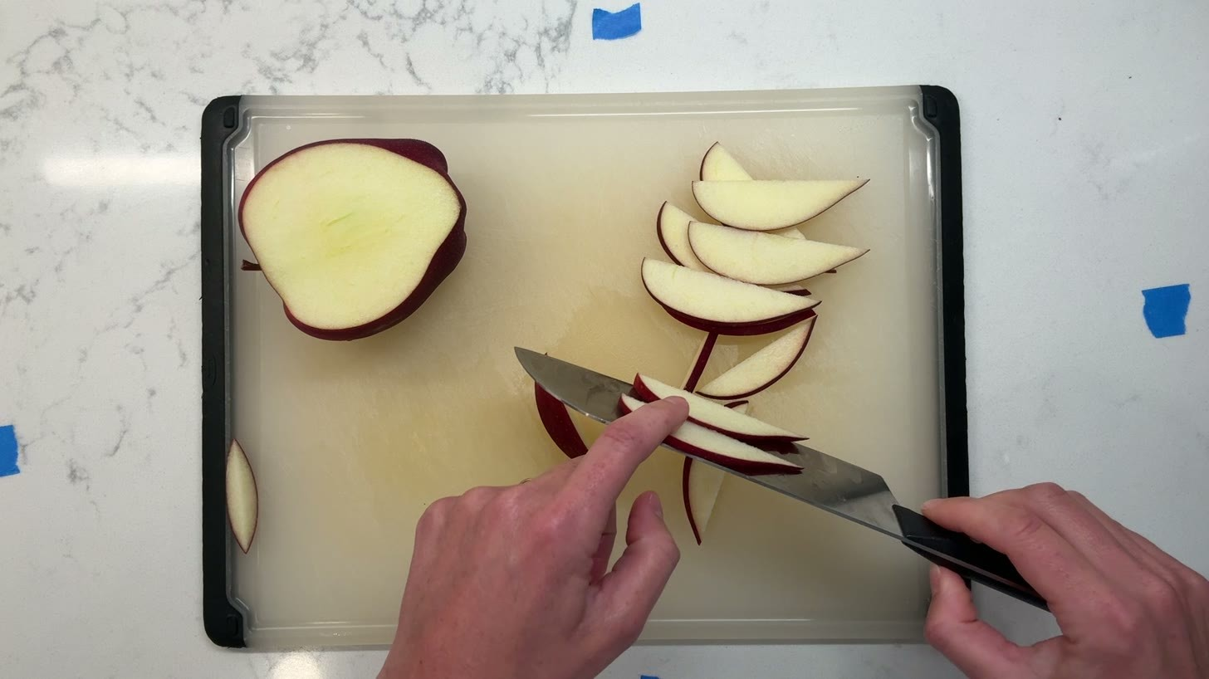
Figure 3.3. a little piece too small to take as a slice — molly2, t=27s
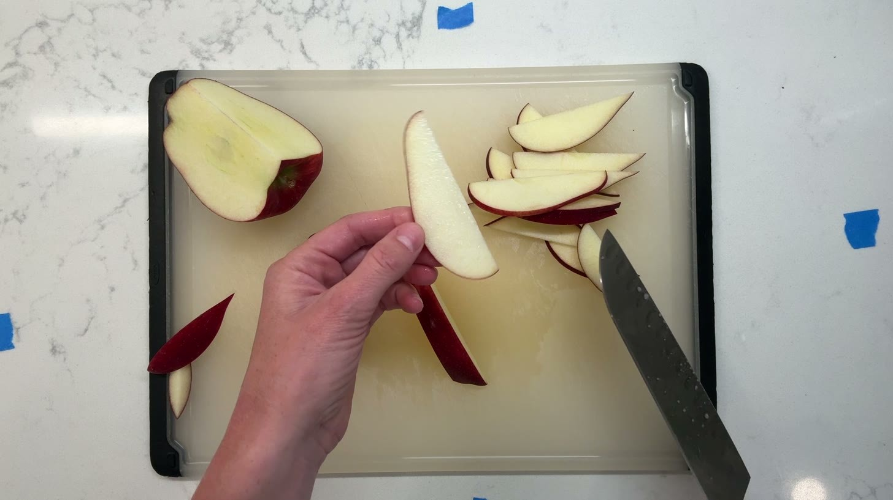
Figure 3.4. the slice was too thin — molly2, t=58s

3.3 Check and tidy the slices
3.3.1 Periodically check both sides of the blade to confirm each slice is a consistent, correct size before making the next cut.
3.3.2 Use the flat of the knife blade, or the fingers, to nudge the fanned slices into a tidy row on the board as they accumulate.
Decision points
If | Then
the cut slices are spreading unevenly across the board | nudge them into a tighter, aligned row using the flat of the blade or fingers

4. Clear the board
Finish work on the apple by clearing scrap, core piece, and slices from the board.
Observed in 1 of 3 runs.
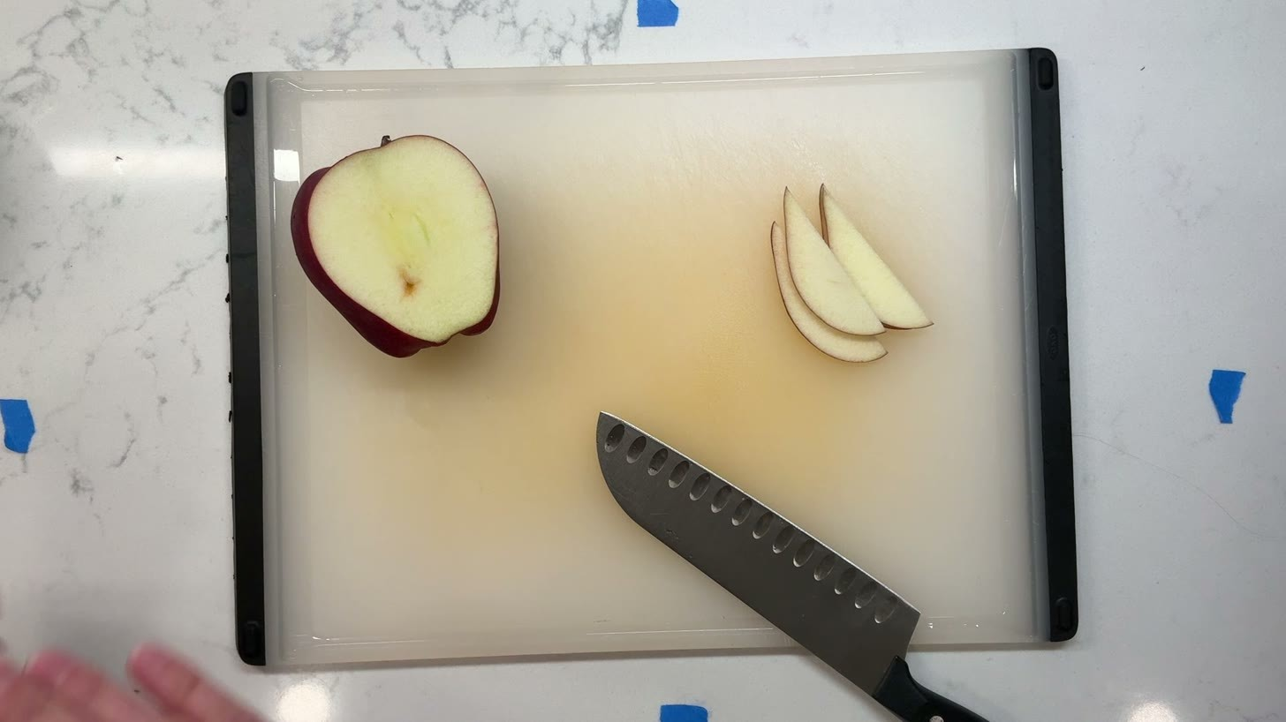
Figure 4.1. Clear the board — molly3, t=42s

4.1 Conclude slicing
4.1.1 Place the final slice into the fan of slices.
4.1.2 Withdraw both hands from the board, leaving the finished pieces in place.

4.2 Remove scrap and pieces from the board
4.2.1 Lift the scrap from the corner of the board and carry it off the working area.
4.2.2 Lay the knife down flat near the edge of the board.
4.2.3 Gather the fanned slices and carry them off the board.
4.2.4 Lift the remaining scrap pieces and the core piece off the board in turn.
4.2.5 Sweep any remaining slice off the board, leaving only the knife.

